
Internal Assessment Resource
Geography Level 1
EXPIRED
This resource supports assessment against:
Achievement Standard 91014 version 2
Apply spatial analysis, with direction, to solve a geographic problem
Resource title: Location, Location
3 credits
This resource:
- Clarifies the requirements of the standard
- Supports good assessment practice
- Should be subjected to the school’s usual assessment quality assurance process
- Should be modified to make the context relevant to students in their school environment and ensure that submitted evidence is authentic

Date version published by Ministry of Education | February 2015 Version 3  To support internal assessment from 2015
Quality assurance status | These materials have been quality assured by NZQA.  NZQA Approved number A-A-02-2015-91014-02-4436
Authenticity of evidence | Teachers must manage authenticity for any assessment from a public source, because students may have access to the assessment schedule or student exemplar material.  Using this assessment resource without modification may mean that students’ work is not authentic. The teacher may need to change figures, measurements or data sources or set a different context or topic to be investigated or a different text to read or perform.

Internal Assessment Resource
Achievement Standard Geography 91014: Apply spatial analysis, with direction, to solve a geographic problem
Resource reference: Geography 1.8B v3
Resource title: Location, Location
Credits: 3
Teacher guidelines
The following guidelines are supplied to enable teachers to carry out valid and consistent assessment using this internal assessment resource.
Teachers need to be very familiar with the outcome being assessed by Achievement Standard Geography 91014. The achievement criteria and the explanatory notes contain information, definitions, and requirements that are crucial when interpreting the standard and assessing students against it.
Context/setting
The aim of this assessment is for students to investigate, describe, and explain the locations of two contrasting rural or urban functions/services. The context is two contrasting services (retail banking outlets and dairies) in suburban Onehunga.
Students will collect and/or import spatial data about their chosen functions or services using, for example: fieldwork (field notes, GPS waypoints), telephone directories, business directories, Google Earth, Google Maps, other Internet sources, interviews.
The students will use Google Earth to present and manipulate spatial information, analyse their findings, and present them in visual form on an A3 layout that is accompanied by a written analysis.
Conditions
This assessment task will take place over two weeks/eight hours of class time.
The KML files that are generated in Google Earth when the data is loaded are easily shared so that in some areas of the country collaboration between schools may be possible.
Students will work individually to manipulate and present spatial data in Google Earth.
Assess students on the quality of the ideas and information in their layout and analysis.
Resource requirements
Assessment resources must be provided by the teacher and should be of sufficient quality to enable students to achieve at Excellence level.
Students need information about two rural/urban functions/services from fieldwork or other sources from which they create place marks and add layers to the view.
They also need access to computers with Google Maps and Google Earth installed. If student work is to be printed, a colour printer is advised for an effective result.
Additional information
You will need to pre-teach:
- key terms: function, urban, rural, patterns, accessibility, services, subjective, objective
- what constitutes a pattern (for example, linear, clustered, or regular)
- recognition of land use patterns from aerial imagery
- factors that might affect the locational patterns of the functions/services chosen. This could lead into a discussion of market thresholds, range of a good, Central Place theory, or Hotelling’s locational-interdependence model
- how to conduct fieldwork
- how to label and annotate images/maps.
Students should have some familiarity with Google Earth and how to create and manipulate data. See the Google Earth section on the following page.
The functions/services chosen should have different locational needs but be in the same area/region.
In urban areas, students could compare:
- dairies and banking outlets
- chemists and clothing stores
- supermarkets and fast food outlets.
In rural areas, students could compare:
- veterinary practices and stores
- pack houses and primary schools
- pubs and secondary schools.
Students may need to access census data about local communities through the Statistics New Zealand Quick Stats About a Place page: www.stats.govt.nz/Census/2006CensusHomePage/QuickStats/AboutAPlace.
A useful teacher reference is Nagel, G. and Spencer, K. (1997). Geographical Enquiries: Skills and Techniques for Geography. Cheltenham: Stanley Thornes.
Google Earth
Students will need to create screen captures of their data and paste these into other programmes, such as Microsoft Word, to present their final layout.
Using Google Earth, students will need to know how to:
- create folders
- organise data into folders
- create place marks using appropriate symbols, colours, and sizes
- change place mark symbols so that all examples of a given function are displayed in the same way
- turn layers on/off
- create polygons
- measure distances using the ruler
- tilt and zoom in/out in the view
- save and export files/folders.
Students should know how to set up a folder in their own workspace in which to save the features they create. They also need to know how to save these features into this workspace, as well as in My Places in Google Earth.
For some tasks Google Maps may be useful. Students can access this via Google Earth.
Teachers will need to decide how students will present the Google Earth files and final presentations for assessment viewing. It is possible to assess all of this work on screen after students save their work to a central location or on disk.
A useful website about Google Earth is:
http://www.geography.org.uk/cpdevents/onlinecpd/gis/gisorvisualisation/#top.

Internal Assessment Resource
Achievement Standard Geography 91014: Apply spatial analysis, with direction, to solve a geographic problem
Resource reference: Geography 1.8B v3
Resource title: Location, Location
Credits: 3
Achievement | Achievement with Merit | Achievement with Excellence
Apply spatial analysis, with direction, to solve a geographic problem. | Effectively apply spatial analysis, with direction, to solve a geographic problem. | Comprehensively apply spatial analysis, with direction, to solve a geographic problem.
Student instructions
Introduction
This assessment requires you to identify the key features of the locations of retail banking outlets and dairies in Onehunga to solve a client’s geographic problem.
You have been contracted by Locus Loci Ltd to analyse the locations of retail banking outlets and dairies in the Onehunga suburban area. They are considering establishing another bank for a new client and building one or more new dairies in Onehunga. They want an analysis of the key features the current locations of each service have in common so they know what they should look for.
You may work collaboratively to collect data about the present locations of the banking outlets and dairies in Onehunga. You will work individually to analyse the data and produce a layout containing images/maps, and a written report.
You will be assessed on how well you are able to apply spatial analysis to solve this geographic problem.
This activity takes place over two weeks of class time.
The work is due on <teacher to insert due date here>.
Teacher note: Adapt details of this introduction to suit your chosen context.
Task
Read Resource A before you begin this work.
Refer to Resource B for further guidance and information as you work.
Create, collect, and manipulate spatial data
Collect data
Find out the present locations of all the retail banking outlets and dairies in Onehunga.
Teacher note: Tell students whether you want them to do this through fieldwork or other methods.
Map the locations
Use Google Earth to show details of the current locations of all the banking outlets and dairies in Onehunga.
Create one or more images/maps that effectively and accurately show the location of the banking outlets and dairies.
Take one or two screen captures and add these to your layout.
Describe the locations
Study the overall pattern of the current locations of all the banking outlets and dairies in Onehunga.
On your own paper/workspace, describe the patterns shown.
Save your answers as part of your written analysis.
Explain the locations
Using Google Earth, zoom in and examine the locations of the banking outlets and dairies in more detail. Use Google Maps if you need to.
Make notes about the features of these locations that help explain why the banking outlets and dairies are located where they are (for example, space for car parks).
Take at least one screen capture each for the banking outlets and for the dairies to show factors that help explain the locations of each service.
Add these to your layout.
Produce images/maps that show the locations and distribution patterns
Produce images/maps for your layout that show where the banking outlets and the dairies are found in Onehunga.
Add to your screen captures:
- annotations that point out key features that help explain the locations
- the usual mapping conventions.
Organise your layout so it is effective and interesting to look at.
Analyse your data
Provide a report for Locus Loci Ltd that clearly describes and explains the key features in the locations of the retail banking outlets and dairies in Onehunga.
Add your responses to your written analysis.
Hand in your work
Hand in your:
- A3 layout containing images/maps
- written analysis.
Include a cover sheet with your name and assessment details on it.
Resource A: What’s so important about location?
Different functions and services often have different needs. Therefore they are found in different locations.
For example, large-format stores such as The Warehouse are often found on the outskirts of a town and in conjunction with similar outlets (a retail park). These outlets or retail parks rely on attracting customers who drive to this destination, and therefore they have large parking areas.
In contrast, dairies are found throughout a suburb or town, frequently in primarily residential streets. They may have one or two short-term (10-minute) car parks directly in front. It would be unusual for two dairies to be very close to each other, but a dairy may be found close to the local supermarket.
Think about the reasons for these different locations.
Deciding where to locate a service or function such as a retail banking outlet and a dairy needs careful thought so the location best meets the needs of the people who use each service and the needs of its owners.
Resource B: Further guidance
Setting up Google Earth
Create a folder
In your own workspace, create a folder where you can save the data you create. Your teacher will tell you how to name this folder.
Set up Google Earth
Open Google Earth and create a new folder titled “Location”.
Go to Tools > Options > Show Lat/Long. Check Degrees, Minutes and Seconds.
Go to Tools > Options and ensure that the terrain quality is set to Higher.
Save your work
Save the folders and features you create in Google Earth into the folder in your workspace. Remember to save your work in My Places in Google Earth before logging off.
Prepare your layout
Prepare an A3 document in a suitable computer application (for example, Microsoft Word, Pages, or InDesign) into which you will paste your maps/images.
Save this document in your workspace folder.
Creating, collecting, and manipulating spatial data
Locating the banking outlets and dairies
In your Location folder in Google Earth create a folder. Name it “Banking Outlets”.
In this folder create a set of place marks to show the present locations of all the banking outlets in Onehunga.
Change the icon for these place marks to a small circle/square/triangle. Make the label text smaller and ensure all these place marks are shown the same way.
Make another folder in your Location folder and create a set of place marks to show the present locations of all the dairies in Onehunga.
Change these icons to display using smaller labels and a symbol different from the symbol for the banking outlets.
Decide whether you need to display the names of roads, towns, and so on. If so, turn them on in the layers.
Zoom out to the full extent of the area you are investigating. Use the Add Polygon icon to draw a polygon to show the extent of this area. Set the colour to opaque.
Save your work.
Describing the locations
Comment on:
- how many banking outlets and dairies there are
- where the banking outlets and dairies are located
- how far apart each of the banking outlets and each of the dairies is located
- whether you think they are located in a pattern, and, if so, in what type of pattern.
Analysing your data
Your written analysis needs to be valid, detailed, and based on information shown on your layout.
You need to:
- check that your descriptions of the locations of the banking outlets and the dairies are complete
- write paragraphs to explain why the banking outlets and dairies are found where they are, and suggest reasons for any patterns shown.
Make sure that you:
- refer to the images/maps on your layout
- include specific details in your answer, such as specific roads and the location of nearby businesses.

Assessment schedule: Geography 91014 Location, Location
Evidence/Judgements for Achievement | Evidence/Judgements for Achievement with Merit | Evidence/Judgements for Achievement with Excellence
The student applies spatial analysis, with direction, to solve a geographic problem for Locus Loci Ltd by describing the current locations of banking outlets and dairies in Onehunga and describing the features that make these locations suitable.  The student successfully and accurately creates a polygon and some (about half) of the place marks for both features and saves these to My Places in the view OR successfully and accurately creates a polygon and most place marks for one feature and saves these in the view.  The student creates and includes one to three images/maps in their layout to show the locations of banking outlets and dairies in Onehunga.  There is at least one annotated image/map for each function that helps to explain the locations of each function.  Some of the maps/images required are completed to a good standard to show the information OR the student includes all required maps/images, but several are missing information.  The student describes the locations of the banking outlets and dairies in Onehunga, identifying key location features. The student refers to maps and/or images.  The comments are valid but lack detail.  Example (partial):  Layout  See Appendix A. Note that this example is at Merit level.  Report extract  “There are nine dairies in Onehunga. They are found all around the area. Fig. 1 shows that five of the dairies are located on corners. Two more are almost but not quite on a corner. These are the Tin Tacks Superette and the Church Street Dairy. All dairies are on main roads.  “I think the pattern is a regular one. They have similar location features.  “There are six banking outlets in Onehunga. As Fig. 2 shows, they are all located on the Mall and are all close to each other. They are in a clustered pattern.  “The dairies have several locational features in common. First, they are all on main roads. The Alfred St and Devon dairies are examples of this. Five dairies are on corners.  “Almost all of the dairies have car parks right outside them.  “The dairies are mostly surrounded by houses. This is shown in Fig. 3.  “The banking outlets are all clustered together in the Mall. They are all on the main retail street, the Mall. This is quite central to the whole of Onehunga.  “The banking outlets are very close to each other, as shown on Fig. 2. They are all within 200 metres.” | The student effectively applies spatial analysis, with direction, to solve a geographic problem for Locus Loci Ltd by describing the current locations of banking outlets and dairies in Onehunga and explaining the features that make these locations suitable.  The student successfully and accurately creates a polygon and most place marks for both features and saves these to My Places in the view OR successfully and accurately creates a polygon and most place marks for one feature and saves these in the view.  The student creates and includes two or more images/maps in their layout to show the locations of banking outlets and dairies in Onehunga.  There is at least one annotated image/map for each function that helps to explain the locations of each function.  The student completes the required maps/images and includes them on the layout. The maps/images show the information accurately, and most of the appropriate conventions are evident.  The student explains the location features of the banking outlets and dairies in Onehunga. The student refers to maps and/or images.  The comments are valid and include some detail.  Example (partial):  Layout  See Appendix A. Note that this example is at Merit level.  Report extract  “There are nine dairies in Onehunga. They are found all around the area. Fig. 1 shows that five of the dairies are located on corners. Two more are almost but not quite on a corner. These are the Tin Tacks Superette and the Church Street Dairy. All dairies are on main roads, such as Mt Smart Rd.  “I think the pattern is a regular one. They have similar location features.  “There are six banking outlets in Onehunga. As Fig. 2 shows, they are all located on the Mall and are all within 200 metres of each other. They are in a clustered pattern.  “The dairies have several locational features in common. First, they are all on main roads. This is so that they are easy to get to. The Alfred St and Devon dairies are examples of this. Five dairies are on corners. This means that they are easily seen.  “Almost all of the dairies have car parks right outside them, for example, the Jellicoe Park Dairy. This means that people who have seen the dairy can actually stop their car and park it while they go into the dairy.  “The dairies are mostly surrounded by houses. This is important because many customers will be people who live near the dairy.  “The banking outlets are all clustered together in the Mall. They are all on the main retail street, the Mall. This is quite central to the whole of Onehunga, so the banking outlets are central to their customers, who may need to take actual money to be banked. Being on the Mall also makes them easy to see, and there is parking right outside all of the banking outlets, so they are more accessible to customers.  “For security reasons the banking outlets need their own front and rear entrances. This allows money to be easily collected by security vans.  “The banking outlets are very close to each other, as shown on Fig. 2. They are all within 200 metres. This may be because they compete with each other for customers.” | The student comprehensively applies spatial analysis, with direction, to solve a geographic problem for Locus Loci Ltd by describing the current locations of banking outlets and dairies in Onehunga and explaining in detail the features that make these locations suitable.  The student successfully and accurately creates a polygon and place marks for both features and saves these to My Places in the view.  The student creates two or more images/maps that show the locations of banking outlets and dairies in Onehunga and includes them in their layout. There is at least one image/map for each function that helps to explain the locations of each function.  The student completes the required maps/images and includes them on the layout. The maps/images show the information accurately, using appropriate mapping conventions.  The student presents a detailed and comprehensive explanation of the location features of banking outlets and dairies in Onehunga. The student refers to maps/images to provide locational detail.  The comments are valid and include good detail.  The student refers to specific examples of banking outlets and dairies in Onehunga and to local place names.  Example (partial):  Layout  See Appendix A. Note that this example is at Merit level.  Report extract  “There are nine dairies in Onehunga. They are found all around the area, although there are none in the southern industrial/commercial area. This is a surprise because there is probably a demand for them here for workers to buy lunch. Fig. 1 shows that five of the dairies are located on corners. Two more are almost but not quite on a corner. These are the Tin Tacks Superette and the Church Street Dairy. All dairies are on main roads such as Mt Smart Rd.  “I think the pattern is a regular one. The dairies are evenly spread out, between 290 metres and 640 metres apart. They have similar location features.  “There are six banking outlets in Onehunga. As Fig. 2 shows, they are all located on the Mall–the main street–and are all within 200 metres of each other. They are definitely in a clustered pattern.  “The dairies have several locational features in common. First, they are all on main roads. This is so that they are easy to get to. The Alfred St and Devon dairies are examples of this. Five dairies are on corners. This means that they are easily seen, so that people driving past can see them and stop and buy things. Fig. 3 shows this for the Mt Smart Rd and Jellicoe Park dairies.  “Almost all of the dairies have car parks right outside them, for example, the Jellicoe Park Dairy. This means that people who have seen the dairy can actually stop their car and park it while they go into the dairy.  “Apart from the Devon Dairy, the dairies are surrounded by houses. This is also seen in  Fig. 3. This is important because many customers will be people who live near the dairy.  “I think the dairies are regularly distributed. They cannot be too close together because there may not be enough customers for each dairy if they are, and they all have very similar locational features, for example, being on corners and main roads, which are not random.  “The banking outlets have a very different pattern. They are all clustered together in the Mall. They have different needs from dairies. They are all on the main retail street, the Mall. This is quite central to the whole of Onehunga, so the banking outlets are central to their customers, who may need to take actual money to be banked. Being on the Mall also makes them easy to see, and there is parking right outside all of the banking outlets, so they are more accessible to customers. Also, people are prepared to travel further to a bank, so they can all be together in the Mall, rather than spread around Onehunga.  “For security reasons the banking outlets need their own front and rear entrances. This is shown in Fig. 4. This allows money to be easily collected by security vans.  “The banking outlets are very close to each other, as shown on Fig. 2. They are all within 200 metres. This may be because they compete with each other for customers.”
Final grades will be decided using professional judgement based on a holistic examination of the evidence provided against the criteria in the Achievement Standard.
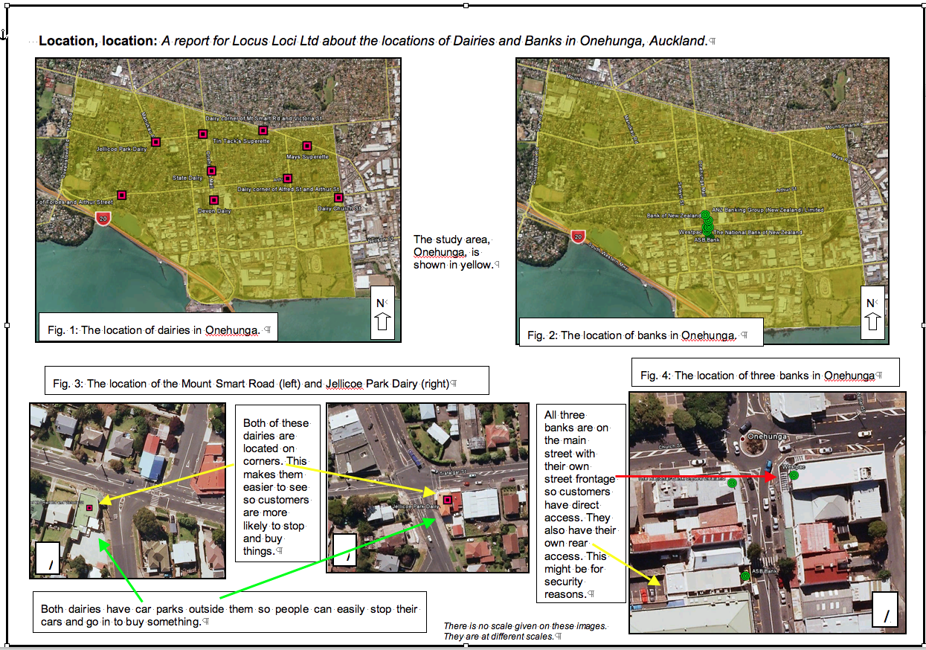
Appendix A: Example layout (Merit)

